**ODD 2020**

**Tutorial Sheet - 3**

**Software Development Fundamentals – I (15B11CI111)**

|  |  |
| --- | --- |
| **Course Outcomes (CO)** | |
| **CO1** | Explain various phases of software development life cycle |
| **CO2** | Explain various data types, memory allocation schemes, precedence of arithmetical and logical operations, and need of array, and structures |
| **CO3** | Draw the flow chart and write the high level code for different problems |
| **CO4** | Apply and implement functions with or without pointers for different problems |
| **CO5** | Demonstrate and implement various operations like traverse, insertion, deletion, *etc.* on files |

**Note: Students are advised to submit their solutions to their respective tutorial faculties**

**Q1. [CO3]** One out of 8 coins is fake (fake coin is lighter). How many weighing are required to identify the fake coin? Write the C program displaying the fake coin and required weighing.

**Q2. [CO3]** One, out of N (N ≥ 6) coins is fake, which may be lighter or heavier. You have a two pan weighing scale, but without weights. No need to detect the fake coin, in minimum weighing, just identify whether it is heavier or lighter. Draw the complete Flow chart for given problem.

Considering that there are 7 (odd) coins OR 8 (even) coins, write a C program to implement the mentioned problem and display whether fake coin is heavier or lighter

**Q3. [CO3]** In India, income tax which is to be paid annually by every individuals is computed as per following rules:

Income Up-to Rs. 2,50,000 🡺 No Tax

Income > Rs. 2,50,000 and < 5,00,000 🡺 0 + @ 5% for income > 250000

Income > Rs. 5,00,000 and < 10,00,000 🡺 12500 + @ 20% for income > 500000

Income > Rs. 10,00,000 🡺 112500 + @ 30% for income > 1000000

Based on your savings, you get rebate/relaxation on following:

Home Loan Interest Repayment 🡺 up-to Rs. 2,00,000

Standard Deduction 🡺 Rs. 50,000

Draw the flow chart and write C program to compute the income tax to be paid by an individual, if he/she input following: Annual income, and House Loan Interest repayment (it can be any amount but capped to maximum Rs 2,00,000)

**Q4. [CO3]** It is desired to find out how much sensitive an area is for Covid19. Following rules are to be applied for analysing the sensitivity:

Least Sensitive: If, less than 20 cases in last 14 days

Sensitive: If cases are in between 21 and 50 in last 14 days

Highly Sensitive: If cases are more than 50 in last 14 days

Draw the flow chart and write C program to input last 14 days count of Covid19 cases in an area and display how much sensitive that area is for Covid19.

**Q5. [CO1]** 8 Puzzle is one of the well-known problems, where 8 numbers (ranging from 1 to 8) are placed in 8 tiles/grids out of 9 tiles/grids in given 3 × 3 square board/grid and one tile/grid is empty so that numbered tiles/grids can be moved/slide using empty tile. Depending on the position of the empty tile/grid, we can slide maximum 4 adjacent (Left, Right, Up, and Down) tiles into the empty tile/grid.

For some initial grid state it is possible to obtain the final/goal grid state. Also, for some initial grid state it is not possible to obtain the final grid state, *i.e.* solution is not possible or infeasible. How to find out for any initial state and final state, the solution is feasible or not?

**Q6. [CO1]** You have been given following two initial states in the 8 Puzzle problem and the final/goal state. Which one of the following correctly states the feasibility to solve the problem?

Initial State 1 (IS1)

|  |  |  |
| --- | --- | --- |
| 1 | 2 | 3 |
| 4 | 5 | 6 |
|  | 8 | 7 |

Initial State 1 (IS2)

|  |  |  |
| --- | --- | --- |
| 2 | 1 | 3 |
| 4 | 5 | 6 |
|  | 8 | 7 |

Final/Goal State 1 (FS)

|  |  |  |
| --- | --- | --- |
| 1 | 2 | 3 |
| 4 | 5 | 6 |
| 7 | 8 |  |

1. Solution of IS1 is feasible only
2. Solution of IS2 is feasible only
3. Solution of both IS1 and IS2 are feasible
4. Solution of neither IS1 nor IS2 is feasible

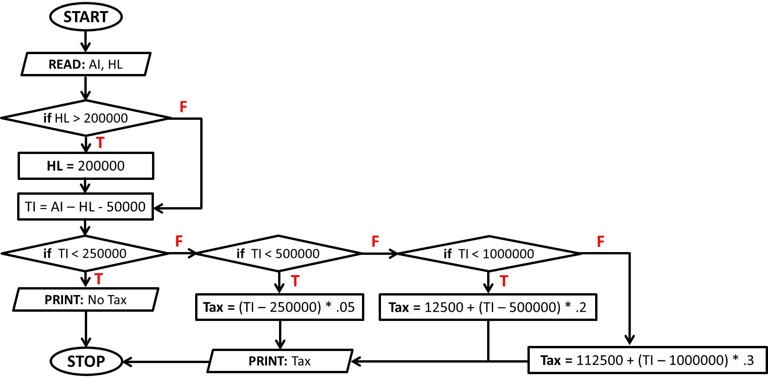

#include<stdio.h>

int main()

{

int AI, HL, TI;

float Tax;

printf(“Enter Annual Income and Home Loan Interest Repayment”);

scanf(“%d %d”, &AI, &HL);

if(HL > 200000) {HL = 200000;}

TI = AI – HL – 50000;

if(TI < 250000) {printf(“No Tax”); }

else

{

if(TI < 500000) {Tax = (TI – 250000)*.05; }

else if(TI < 1000000) {Tax = 12500 + (TI – 250000)*.2;}

else {Tax = 112500 + (TI – 250000)*.3; }

printf(“%d”, Tax);

}

return 0;

}